Resource 1: Sample logic models and evaluation frameworks
Public safety infrastructure projects will typically have aims focused on (1) improving public safety and security and/or (2) improving community confidence and perceptions of safety. These aims are stipulated in the Public Safety Infrastructure Fund (PSIF) funding guidelines and agreements and underpin the overall aim of the PSIF grants program.
Individual projects delivered by local council may prioritise specific aims depending on the interventions involved and the target problem being addressed. Three simple logic models and evaluation frameworks have been developed and are presented below to describe the most common project types funded under the PSIF grants program. Specifically:
- Installation of new or additional CCTV systems and signage (Figure 1 and Table 1)
- Installation or improvement of lighting (Figure 2 and Table 2)
- Urban development and design interventions (e.g. wayfinding, landscaping, mixed use developments) (Figure 3 and Table 3)
Separate logic models have been developed for the three types of projects because of the different mechanisms that underpin each intervention and the outputs required to ‘activate’ these mechanisms. For example, the improvement of lighting will influence safety differently to CCTV and urban renewal projects, but will deliver a similar outcome.
These logic models and evaluation frameworks have been developed to assist you in planning for the evaluation of your public safety infrastructure project. You will need to develop a logic model and evaluation framework for your own project. You can select the outputs and outcomes from the examples provided that are most relevant to your work (and exclude those that are not), and then use the relevant evaluation questions, performance indicators and data sources to help guide your evaluation. You can still adapt these to better suit your own project, if you feel it’s necessary.
If your project involves more than one type of intervention (eg CCTV and lighting), then you can draw on both logic models. In most cases, there are consistent outcomes across the different types of projects. Where they differ is in the outputs required to produce this outcome. You will therefore need to include the relevant outputs. For example, if you are implementing a project involving CCTV and lighting, then you will probably include the outcome ‘The community perceives the area to have better surveillance and there is an increased use of the area for legitimate purposes’ in your own logic model. You will then need to include the relevant outputs from both project types—‘CCTV systems and signage that are clearly visible are installed and their location is publicised’ (for CCTV) and ‘Lighting is installed to illuminate areas where there are crime and safety concerns’ (for lighting)—within your logic model and evaluation framework.
A separate template (Resource 2) has been developed to assist you in preparing an evaluation plan, including the evaluation framework, for your project.
Part A—Installation of new or additional CCTV systems and signage
There are three mechanisms that explain how CCTV may contribute to a reduction in crime and antisocial behaviour and an improvement in community confidence and perceptions of safety.
- Reassurance mechanism: CCTV may improve perceptions of safety by giving the community confidence that offenders are unlikely to offend in an area with CCTV due to the heightened risk of detection. In order for this to be achieved, the community must be aware that the CCTV is in operation and must believe that offenders are likely to be deterred by CCTV. When the community has greater confidence in an area, pedestrian activity increases. The increased flows of people act as ‘capable guardians’ thereby increasing natural or informal surveillance, which further works to enhance community confidence and deter potential offenders.

- Deterrence mechanism: CCTV may reduce the incidence of crime and antisocial behaviour by deterring offenders from committing a crime in areas where CCTV is installed. This assumes that offenders rationally weigh up the costs and benefits of committing a crime and the presence of CCTV is included in that risk assessment. In areas where there are visible indications that CCTV is in operation, offenders will think twice about committing an offence and decide that the risk of detection is too great. (Note: It is enough that offenders perceive that they are being detected, even if active monitoring of the system is not taking place).

- Investigative mechanism: CCTV may improve safety by enabling more effective collection of evidence to assist Police in their investigations. This acknowledges that criminal investigations and prosecutions are often challenged by a lack of clear evidence. In areas where quality CCTV footage is collected and stored and partnership arrangements between CCTV operators and Police exist to facilitate footage retrieval, the ability to identify and prosecute offenders is enhanced.

Figure 1 Logic model describing CCTV projects funded under the Public Safety Infrastructure Fund
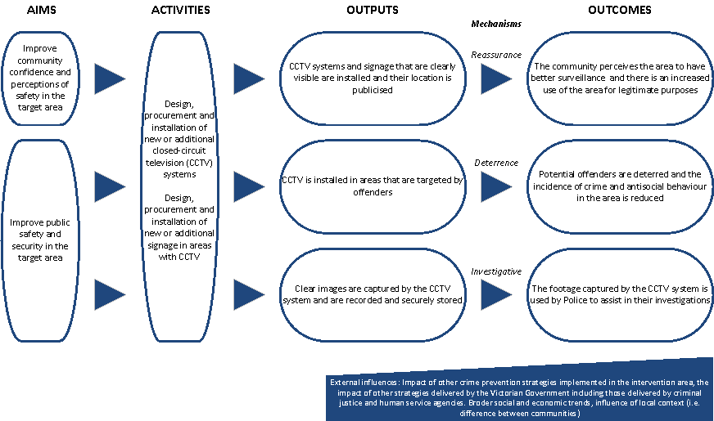

Table 1 Evaluation framework for CCTV projects funded under the Public Safety Infrastructure Fund
Project component | Evaluation questions | Key performance indicators | Data collection  (method and source) | Timeframe for data collection
CCTV systems and signage that are clearly visible are installed and their location is publicised (output) | How many signs have been erected in the areas surrounding the CCTV systems?  Are the cameras and signs unobstructed and clearly visible? | Number of signs located in areas monitored by CCTV  Extent to which signs are visible to users of the public space | Observation / audit of area and supporting evidence such as audit reports and photographs | After installation of CCTV
 | To what extent have the CCTV systems been advertised? | Number and type of advertisements of the CCTV system | Administrative records of council | After installation of CCTV
The community perceives the area to have better surveillance and there is an increased use of the area for legitimate purposes (outcome) | Are more people using the area for legitimate purposes since the CCTV was installed? | Number of pedestrians passing through the area before and after CCTV was installed  Type of activities undertaken by pedestrians using the area (positive and negative activities including exercising, community events, drinking / rowdy behaviour etc.) | Pedestrian activity data collected through observation at specified time periods (morning, afternoon, evening, late at night) | Pedestrian counts should be recorded over a 2 week period pre and post CCTV installation.  Information should also be recorded on the types of activities undertaken by users of the space, pre and post implementation of CCTV.
 | To what extent has there been an improvement in feelings of safety for business operators and community members working or spending time in the area with CCTV? | Proportion of business operators and members of the community who feel safe working and spending time in the area with CCTV | Community safety survey or interviews with business operators and community | Before and after CCTV installation
CCTV is installed in areas that are targeted by offenders (output) | How many cameras have been installed and in what locations? | Density of recorded criminal incidents (property, violent, antisocial behaviour) per square metre across the target area | Administrative information from council  System blueprint and technical specifications, provided by technical consultation | After installation of CCTV
 | What is the nature and severity of crime and disorder problems occurring in the target area? | Level and nature of crime and safety problems reported by business operators and community members before the CCTV was installed | Community safety survey or interviews with business operators and community | Before installation of CCTV
Potential offenders are deterred and the incidence of crime and antisocial behaviour in the target area is reduced (outcome) | To what extent has there been a reduction in property and violent crime in the area where CCTV is installed? | Number of recorded property offences (break and enter, stealing motor vehicle, steal from motor vehicle, theft and property damage); violent offences (assault) in the target area | Police recorded crime data provided by the Crime Statistics Agency Victoria | Data should be collected for an equivalent period before and after the project has been implemented.  Data can be sought post-implementation
 | To what extent has there been a reduction in general disorder and antisocial behaviour in the area where CCTV is installed? | Number of recorded incidences that relate to general disorder and antisocial behaviour (disorderly and offensive conduct, drug use and possession, public nuisance) in the target area | Police recorded crime data provided by the Crime Statistics Agency Victoria | Data should be collected for an equivalent period before and after the project has been implemented.  Data can be sought post-implementation
 | To what extent has there been a reduction in the incidence (and seriousness) of crime and antisocial behaviour in areas immediately surrounding the target area? | Number of recorded offences (as listed above) in areas immediately surrounding the location with CCTV | Police recorded crime data provided by the Crime Statistics Agency Victoria | Data should be collected for an equivalent period before and after the project has been implemented.  Data can be sought post-implementation
Clear images are captured by the CCTV system and are recorded and securely stored (output) | What are the storage procedures for the footage captured on the CCTV systems? | Storage and archival policies and procedures | Administrative information from council | After installation of CCTV
 | Is the footage captured of reasonable quality? | Technical specifications of the CCTV system (e.g. black and white vs. colour imaging, storage capacity, dosage/coverage) | System blueprint and technical specifications, provided by technical consultation | After installation of CCTV
 | To what extent has audit activity helped to identify areas and strategies for improvement | Recommendations from audit activity implemented | Interviews with key police and operator personnel | After audit of system
The footage captured by the CCTV system is used by Police to assist in their investigations (outcome) | To what extent has the footage captured by the CCTV system assisted Police in their investigations? | Proportion of Police that are satisfied with the process for requesting and accessing footage  Proportion of Police that believe the footage captured is useful in helping investigate incidents | Interviews with key police personnel | After installation of CCTV
 | How many requests for footage have been lodged by Police for evidentiary purposes since the CCTV system was installed? | Number of requests made by Police for access to footage captured by the CCTV system  Proportion of requests for footage that have been met by council | Log of requests for footage maintained by operator / council | After installation of CCTV
 |  | Number of media statements which cite the use of CCTV in apprehending and prosecuting offenders | Log of media statements / articles | After installation of CCTV

Part B—Installation or improvement of lighting
There are two mechanisms that explain how the installation or improvement of lighting may contribute to a reduction in crime and antisocial behaviour and an improvement in community confidence and perceptions of safety.
- Deterrence mechanism: Illuminating dark areas through improvements in lighting acts to reduce crime that occurs at night by increasing visibility. Increased visibility deters potential offenders by increasing the risks that they will be recognised or interrupted, and the presence of Police and other authority figures becomes more apparent. This assumes that offenders make rational decisions about the risks of committing a crime and the propensity for detection and identification is included in that risk assessment.

- Reassurance mechanism: Increased visibility through improvements in lighting also signals to the community that an area is less dangerous after dark. This is because with increased visibility people have a greater awareness of their surroundings and suspicious activity and offending behaviour are more likely to be detected. When the community has greater confidence in an area, pedestrian activity increases. The increased flows of people act as ‘capable guardians’ thereby increasing natural or informal surveillance, which further works to enhance community confidence and deter potential offenders.
Figure 2 Logic model describing lighting projects funded under the Public Safety Infrastructure Fund
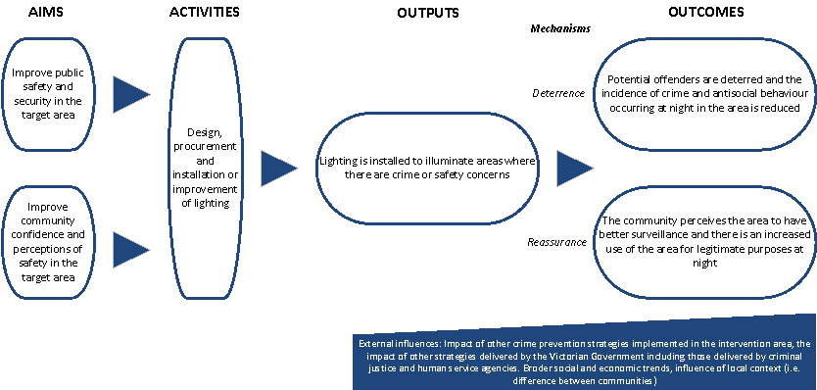

Table 2 Evaluation framework for lighting projects funded under the Public Safety Infrastructure Fund
Project component | Evaluation questions | Key performance indicators | Data collection  (method and source) | Timeframe for data collection
Lighting is installed to illuminate areas where there are crime and safety concerns (output) | How effective are the lights in illuminating the area throughout the duration of the night? | Number and technical specifications of lighting installed including coverage | Technical specifications provided by technical consultant | Commencement of project
 |  | Extent to which lighting has improved visibility in the area at all times of night | Observation / audit of area at night and supporting evidence such as audit reports and photographs | Before and after installation of lighting
Potential offenders are deterred and the incidence of crime and antisocial behaviour occurring at night in the target area is reduced (outcome) | To what extent has there been a reduction in property and violent crime at night in the area where lighting is installed? | Number of recorded property offences (break and enter, stealing motor vehicle, steal from motor vehicle, theft and property damage); violent offences (assault) in the target area at night | Police recorded crime data provided by the Crime Statistics Agency Victoria | Data should be collected for an equivalent period before and after the project has been implemented.  Data can be sought post-implementation
 | To what extent has there been a reduction in general disorder and antisocial behaviour in the area where lighting is installed? | Number of recorded incidences that relate to general disorder and antisocial behaviour (disorderly and offensive conduct, drug use and possession, public nuisance) in the target area at night | Police recorded crime data provided by the Crime Statistics Agency Victoria | Data should be collected for an equivalent period before and after the project has been implemented.  Data can be sought post-implementation
 | To what extent has there been a reduction in the incidence (and seriousness) of crime and antisocial behaviour in areas immediately surrounding the target area? | Number of recorded offences (as listed above) in areas immediately surrounding the location with lighting at night | Police recorded crime data provided by the Crime Statistics Agency Victoria | Data should be collected for an equivalent period before and after the project has been implemented.  Data can be sought post-implementation
The community perceives the area to have better surveillance and there is an increased use of the area for legitimate purposes at night (outcome) | Are more people using the area for legitimate purposes at night? | Number of pedestrians passing through the area at night before and after the lighting was installed  Type of activities undertaken by pedestrians using the area at night (positive and negative activities including exercising, community events, drinking / rowdy behaviour etc.) | Pedestrian activity data collected through observation at night | Pedestrian counts should be recorded over a 2 week period pre and post lighting installation.  Information should also be recorded on the types of activities undertaken by users of the space, pre and post lighting installation.
 | To what extent has there been an improvement in feelings of safety for business operators and community members working or spending time in the target area? | Proportion of business operators and members of the community that feel safe working and spending time in the target area | Community safety survey or interviews with business operators and community | Before and after lighting installation

Part C—Urban development and design interventions
There are three mechanisms that explain how urban development and design projects may contribute to an improvement in public safety, community confidence and perceptions of safety.
- Deterrence mechanism: Enhancing the physical security of an area through strategies such as building perimeter fencing and installing window coverings and hardened street furniture increases the effort required by offenders to commit crime. As a result, potential offenders are deterred and the incidence of crime and antisocial behaviour is reduced.

- Reassurance mechanism: When increased visibility is created by removing entrapment points and poor sightlines in an area, people have a greater awareness of their surroundings and suspicious activity and offending behaviour are more likely to be detected. This gives the community a greater confidence in the area, which reduces fear of crime.

- Social control mechanism: Highly noticeable changes to the amenity of an area through urban design, renewal or regeneration signals to the community that authorities are in control of an area. By developing areas in ways that appeal to a wide cross-section of the community, there is increased use and ownership of the space. This results in an increase in capable guardianship and the likelihood that the community will detect and report suspicious activity and offending behaviour. The risk for offenders increases and they are subsequently deterred from committing crimes in the area. This assumes that community members are drawn to the area to participate in a variety of activities and highlights the importance of community consultation in planning urban development and design projects.

Figure 3 Logic model describing urban development and design projects funded under the Public Safety Infrastructure Fund
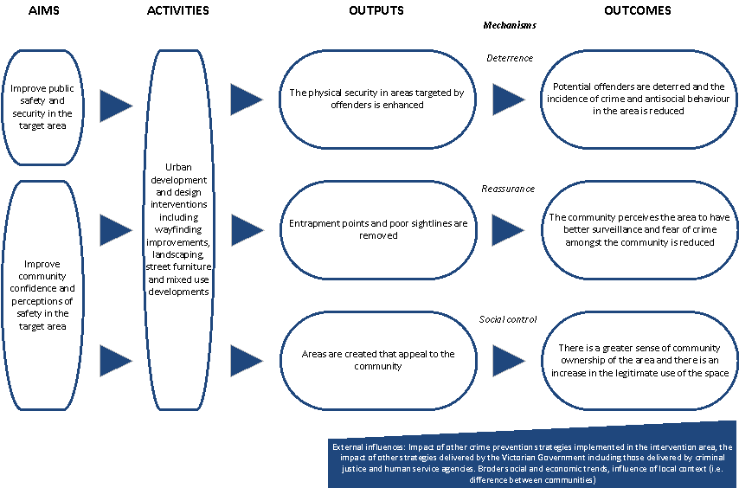

Table 3 Evaluation framework for urban development and design projects funded under the Public Safety Infrastructure Fund
Project component | Evaluation questions | Key performance indicators | Data collection  (method and source) | Timeframe for data collection
The physical security in areas targeted by offenders is enhanced (output) | In what ways has the physical security of the target area been strengthened? | Nature of security measures implemented | Observation / audit of area and supporting evidence such as audit reports and photographs | After project implementation
Potential offenders are deterred and the incidence of crime and antisocial behaviour occurring in the target area is reduced (outcome) | To what extent has there been a reduction in property crime in the target area? | Number of recorded property offences (break and enter, stealing motor vehicle, steal from motor vehicle, theft and property damage) in the target area | Police recorded crime data provided by the Crime Statistics Agency Victoria | Data should be collected for an equivalent period before and after the project has been implemented.  Data can be sought post-implementation
 | To what extent has there been a reduction in general disorder and antisocial behaviour in the target area? | Number of recorded incidences that relate to general disorder and antisocial behaviour (disorderly and offensive conduct, drug use and possession, public nuisance) in the target area | Police recorded crime data provided by the Crime Statistics Agency Victoria | Data should be collected for an equivalent period before and after the project has been implemented.  Data can be sought post-implementation
 | To what extent has there been a reduction in the incidence (and seriousness) of crime and antisocial behaviour in areas immediately surrounding the target area? | Number of recorded offences (as listed above) in areas immediately surrounding the target area | Police recorded crime data provided by the Crime Statistics Agency Victoria | Data should be collected for an equivalent period before and after the project has been implemented.  Data can be sought post-implementation
Entrapment points and poor sightlines are removed (output) | In what ways have entrapment points been removed and sightlines improved? | Number and nature of entrapment points removed and sightlines improved | Observation / audit of area and supporting evidence such as audit reports and photographs | After project implementation
The community perceives the area to have better surveillance and fear of crime among the community is reduced (outcome) | To what extent has there been an improvement in feelings of safety for business operators and community members working or spending time in the target area? | Proportion of business operators and members of the community that feel safe working and spending time in the target area | Community safety survey or interviews with business operators and community | Before and after project implementation
Areas are created that appeal to the community (output) | To what extent is the community satisfied with the appearance and amenity of the area? | Number and proportion of business operators and community members that are satisfied with the urban upgrades  Extent to which business operators and community members attribute changes made as part of the project to their improved perceptions of the area | Community safety survey or interviews with business operators and community | Before and after project implementation
There is a greater sense of ownership of the area within the community and greater use of the public space for legitimate purposes (outcome) | Are more people using the area for legitimate purposes? | Number of pedestrians passing through the area before and after project implementation  Type of activities undertaken by pedestrians using the area (positive and negative activities including exercising, community events, drinking / rowdy behaviour etc.) | Pedestrian activity data collected through observation | Pedestrian counts should be recorded over a 2 week period pre and post project implementation.  Information should also be recorded on the types of activities undertaken by users of the space, pre and post project implementation.
 | Has the project led to further investment or economic activity in the area? | Physical improvements by property owners, increased Council maintenance activity, reduction in the number of empty shops etc | Interviews with council and local business  Observation / audit of area and supporting evidence such as audit reports and photographs | After project implementation

